Program Catalogue | 2023-2024 | دليل البرنامج الدراسي

Name of the University  اسم الجامعة | 

First Cycle – Four Levels – 240 ECTS
Bachelor’s Degree (B.Sc.) - Biology

الدورة الأولى - بكالوريوس علوم أحياء – أربع سنوات – ٢٤٠ وحدة اوربية

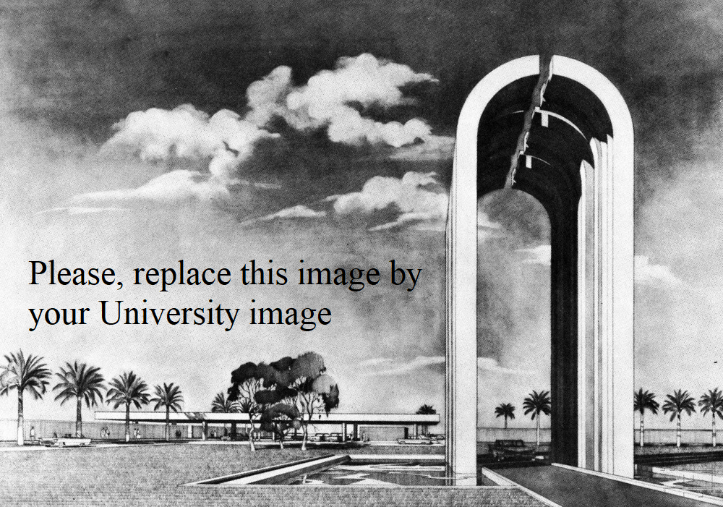

Table of Contents | جدول المحتويات

- Vision & Mission Statement | | بيان الرؤية والرسالة
- Program Goals | | أهداف البرنامج
- Program Specification Overview | | مواصفات البرنامج
- Program learning outcomes | | مخرجات تعلم الطالب على مستوى البرنامج الدراسي
- Academic Staff | | الهيئة التدريسية
- Credits, Grading and GPA | | الاعتمادات والدرجات والمعدل التراكمي
- Modules | | المواد الدراسية
- Contact | | اتصال

Vision & Mission Statement

Vision Statement

To be a distinguished Biology program in Iraq and the region, recognized for academic excellence, innovative research, and preparing qualified graduates who contribute to scientific advancement and sustainable development in life sciences, addressing environmental, health, and agricultural challenges facing our society.

Mission Statement
The Biology Department is committed to:
- Providing high-quality undergraduate and graduate education in biological sciences that meets international academic standards and Bologna Process requirements.
- Fostering scientific research that addresses national priorities in biodiversity, environmental conservation, public health, and biotechnology.
- Developing students' critical thinking, laboratory skills, and ethical scientific practices through modern teaching methodologies and well-equipped facilities.
- Building partnerships with local and international research institutions to enhance knowledge exchange and collaborative research.
- Serving the community through applied research, environmental awareness programs, and evidence-based solutions to biological and ecological challenges.
- Preparing graduates equipped with knowledge and skills needed for careers in research, healthcare, education, environmental management, and industry.

Program Goals
- Ensure graduates master fundamental and advanced concepts in biology aligned with Iraqi higher education standards.
- Develop research capabilities through modern laboratory training and field studies.
- Promote understanding of Iraq's rich biodiversity and environmental conservation needs.
- Prepare students for postgraduate studies and professional careers in life sciences.
- Contribute to sustainable development through applied biological research.

Program Specification Overview

Programme code: | BSc-BIO | ECTS | 240
Duration: | 4 levels, 8 Semesters | Method of Attendance: | Full Time

The Bachelor of Science in Biology is a four-year undergraduate program designed in full compliance with the Bologna Process framework, comprising 240 ECTS credits distributed across eight semesters. The program follows the European Credit Transfer and Accumulation System (ECTS), where one ECTS equals 25 hours of student workload, encompassing lectures, laboratory sessions, self-study, and assessment activities. The curriculum is structured to provide students with a comprehensive foundation in biological sciences, progressing systematically from fundamental concepts in general biology, chemistry, physics, and mathematics during the first year, to specialized disciplines including molecular biology, genetics, microbiology, ecology, and biotechnology in subsequent years. The program allocates 50% of credits to core biology courses (modules), 20% to basic sciences, support and elective modules allowing students to pursue specialized interests, and dedicates significant emphasis to practical training with 30% of credits assigned to laboratory work, field studies, research projects, and professional internships. Students engage with modern teaching methodologies including interactive lectures, hands-on laboratory sessions, field trips, problem-based learning, and a capstone graduation research project that develops their scientific inquiry and research capabilities. The program's learning outcomes are aligned with international standards, ensuring graduates acquire comprehensive knowledge of biological systems from molecular to ecosystem levels, master essential laboratory techniques and research methodologies, develop critical thinking and data analysis skills, and are prepared for diverse career pathways in research, healthcare, environmental conservation, education, and biotechnology sectors, or for pursuing advanced postgraduate studies nationally and internationally.

Program Learning Outcomes
4.1 Knowledge and Understanding (K)
K1. Demonstrate comprehensive understanding of biological concepts at molecular, cellular, organismal, and ecological levels.
K2. Explain fundamental principles of genetics, evolution, and biodiversity.
K3. Describe structure and function of biological systems from molecules to ecosystems.
K4. Understand biochemical and physiological processes in living organisms.
K5. Explain ecological relationships and environmental principles.
K6. Recognize the diversity of life including microorganisms, plants, and animals.
K7. Understand biotechnology applications and their ethical implications.
K8. Comprehend Iraq's biodiversity and environmental conservation needs.

4.2 Intellectual/Cognitive Skills (C)
C1. Apply scientific methodology to biological investigations.
C2. Analyze complex biological problems and develop solutions.
C3. Design and conduct biological experiments appropriately.
C4. Evaluate and interpret scientific literature critically.
C5. Synthesize information from multiple sources.
C6. Apply statistical methods to analyze biological data.
C7. Make evidence-based decisions in biological contexts.
C8. Demonstrate creative thinking in problem-solving.

4.3 Practical and Professional Skills (P)
P1. Perform standard laboratory techniques competently and safely.
P2. Use microscopy and other biological equipment effectively.
P3. Collect, preserve, and identify biological specimens.
P4. Conduct field surveys and ecological assessments.
P5. Apply molecular and cellular biology techniques.
P6. Use bioinformatics tools and databases.
P7. Maintain accurate laboratory records and documentation.
P8. Follow safety protocols and ethical guidelines in research.

4.4 General and Transferable Skills (T)
T1. Communicate scientific information effectively in English and Arabic.
T2. Work collaboratively in teams and lead group projects.
T3. Use information technology and scientific software.
T4. Manage time and resources effectively.
T5. Present scientific findings to diverse audiences.
T6. Search and evaluate scientific literature.
T7. Demonstrate self-directed learning and professional development.
T8. Apply problem-solving skills to real-world situations.

Academic Staff

John Smith | Ph.D. in Biology | Professor
Email:
Mobile no.:

John Smith | Ph.D. in Biology | Professor
Email:
Mobile no.:

John Smith | Ph.D. in Biology | Assistant Prof.
Email:
Mobile no.:

.
.
.

.
.
.

.
.
.

Credits, Grading and GPA
Credits
(Name) University is following the Bologna Process with the European Credit Transfer System (ECTS) credit system. The total degree program number of ECTS is 240, 30 ECTS per semester. 1 ECTS is equivalent to 25 hrs student workload, including structured and unstructured workload.

Grading
Before the evaluation, the results are divided into two subgroups: pass and fail. Therefore, the results are independent of the students who failed a course. The grading system is defined as follows:

GRADING SCHEME
مخطط الدرجات
Group | Grade | التقدير | Marks (%) | Definition
Success Group  (50 - 100) | A - Excellent | امتياز | 90 - 100 | Outstanding Performance
Success Group  (50 - 100) | B - Very Good | جيد جدا | 80 - 89 | Above average with some errors
Success Group  (50 - 100) | C - Good | جيد | 70 - 79 | Sound work with notable errors
Success Group  (50 - 100) | D - Satisfactory | متوسط | 60 - 69 | Fair but with major shortcomings
Success Group  (50 - 100) | E - Sufficient | مقبول | 50 - 59 | Work meets minimum criteria
Fail Group  (0 – 49) | FX – Fail | راسب - قيد المعالجة | (45-49) | More work required but credit awarded
Fail Group  (0 – 49) | F – Fail | راسب | (0-44) | Considerable amount of work required
Note:
Note: Marks with Decimal places above or below 0.5 will be rounded to the higher or lower full mark (for example a mark of 54.5 will be rounded to 55, whereas a mark of 54.4 will be rounded to 54. The University has a policy NOT to condone "near-pass fails" so the only adjustment to marks awarded by the original marker(s) will be the automatic rounding outlined above.

ملاحظة: سيتم تقريب العلامات العشرية التي تزيد أو تقل عن ٠.٥ إلى العلامة الكاملة الأعلى أو الأدنى (على سبيل المثال، سيتم تقريب علامة ٥٤.٥ إلى ٥٥، بينما سيتم تقريب علامة ٥٤.٤ إلى ٥٤). لدى الجامعة سياسة لا تسمح بـ "حالات الرسوب القريبة من النجاح"، لذا فإن التعديل الوحيد للعلامات الممنوحة من قبل المصححين الأصليين سيكون التقريب التلقائي الموضح أعلاه.

Calculation of the Cumulative Grade Point Average (CGPA)
- The CGPA is calculated by the summation of each module score multiplied by its ECTS, all are divided by the program total ECTS.
CGPA of a 4-year B.Sc. degree:
CGPA = [ (1st module score x module ECTS) + (2nd module score x module ECTS) + (3rd module score x module ECTS) + … + (last module score x module ECTS)] / 240

Curriculum/Modules
Semester 1 | 30 ECTS | 1 ECTS = 25 hrs
Code | Module | SSWL | USSWL | ECTS | Type | Prerequisite

Semester 2 | 30 ECTS | 1 ECTS = 25 hrs
Code | Module | SSWL | USSWL | ECTS | Type | Prerequisite

Semester 3 | 30 ECTS | 1 ECTS = 25 hrs
Code | Module | SSWL | USSWL | ECTS | Type | Prerequisite

Semester 4 | 30 ECTS | 1 ECTS = 25 hrs
Code | Module | SSWL | USSWL | ECTS | Type | Prerequisite

Semester 5 | 30 ECTS | 1 ECTS = 25 hrs
Code | Module | SSWL | USSWL | ECTS | Type | Prerequisite

Semester 6 | 30 ECTS | 1 ECTS = 25 hrs
Code | Module | SSWL | USSWL | ECTS | Type | Prerequisite

Semester 7 | 30 ECTS | 1 ECTS = 25 hrs
Code | Module | SSWL | USSWL | ECTS | Type | Prerequisite

Semester 8 | 30 ECTS | 1 ECTS = 25 hrs
Code | Module | SSWL | USSWL | ECTS | Type | Prerequisite

Contact
Program Manager:
John Smith | Ph.D. in Biology | Assistant Prof.
Email:
Mobile no.:

Program Coordinator:
John Smith | Ph.D. in Biology | Assistant Prof.
Email:
Mobile no.:



امسح الكود للوصول إلى النسخة الإلكترونية

